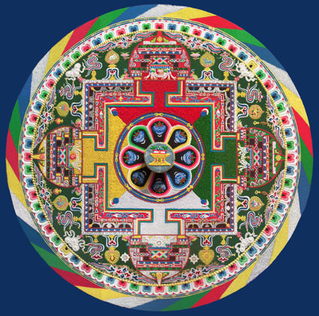

Tibetan Monks
From Drepung Gomang Monastery, Southern India

Visit to Fishers Island
July 17 ~ 19

Sponsored by St. John’s Episcopal Church and the FI Community Center

Tuesday, July 17

6:00 p.m. – Performance of multi-phonic Tibetan chanting at the Fishers Island Community Center.
This features harmonic overtone chanting of traditional prayers, accompanied by temple instruments including horns, flutes, bells, and drums. Delicate hand gestures and other offerings accompany the mystical rituals and multi-phonic singing (each monk chants a chord of three notes).

The monks will also begin construction of small sand mandala. The mandala is an ancient form of Tibetan Buddhism. In general, all mandalas have outer, inner, and secret meaning. On the outer level they represent the world in its divine form; on the inner level, they represent a map by which the ordinary human mind is transformed into the enlightened mind; and on the secret level, they predict the primordially perfect balance of the subtle energies of the body and the clear light dimension of the mind. The creation of a sand painting is said to affect purification and healing on these three levels.

Wednesday, July 18

9:00 – 12:00 p.m./ 2:00 – 4:00 p.m. Mandala Construction continues at the Community Center.

4:30 p.m. Discussion of the principles and practice of Buddhism with St. John’s Book Group. This summer, the group is reading Thich Naht Hanh’s book, Living Buddha, Living Christ. The book group meets at the rectory, Peninsula Road.

Thursday, July 19

10:00 a.m. Mandala Dismantling Ceremony. When the mandala is completed, the final task is to gather the grains of sand and pour them into running water, dispersing the energy of healing and compassion into the universe. This ceremony will begin at the community center and end at the ferry dock.

