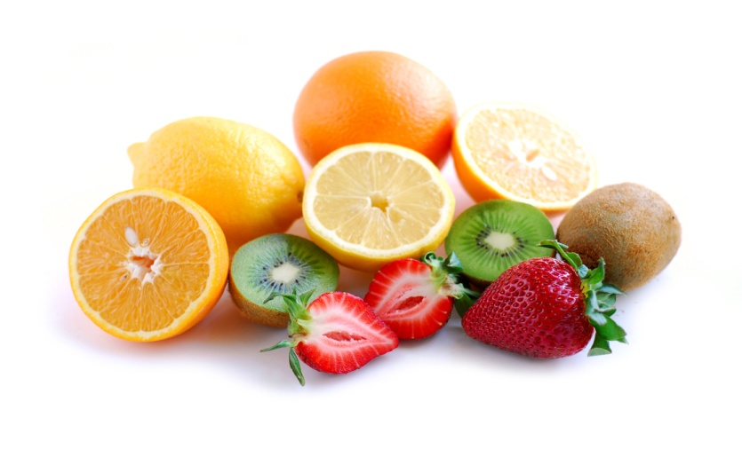

RAW FOOD SEMINAR

Simple delicious ways to get healthier this summer

Presented by
Annie McPhail, Certified Health Coach

Monday July 9th, 2012 @ 6:30 pm

Island Community Center

Enjoy delicious samples and find out:

Why you want more raw food in your diet
How raw food gets you healthier than any cooked alternative
Why with raw food you no longer have to worry about diabetes, blood pressure, IBS, calories, etc.

FREE EVENT!

Any questions? Call Elizabeth (631)788-7683 or Annie (860)287-9980

