[Distributed: May 4, 2012]

The Fishers Island Union Free School
Board of Education
Annual Budget Vote & Elections


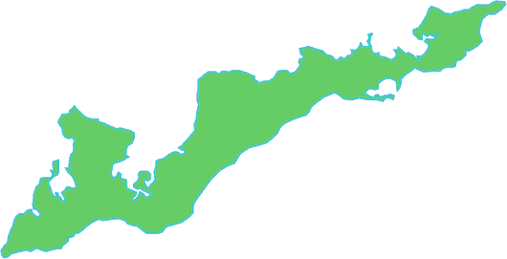

Date: May 15, 2012
Time: Polls will be open 3:00 PM to 9:00 PM
Location: School Gymnasium

Board of Education

Stephanie Hall, President

Sara McLean, Vice President

Jamie Doucette

Laurie Finan

Contact Information for Board of Education

Member Home Phone Email

Jamie Doucette 788-5507 jamie_doucette@yahoo.com

Laurie Finan 788-7412 finan@fishersisland.net

Stephanie Hall 788-7447 Stephanie.K.Hall@pfizer.com

Sara McLean 788-7650 srmcl@mac.com

Schedule of Regular Meetings 2011-2012

July 6, 2011 January 18, 2012

July 27, 2011 February 15, 2012

August 17, 2011 March 21, 2012

September 21, 2011 April 19, 2012

October 19, 2011 May 1, 2012 Budget Hearing

November 16, 2011 May 15, 2012 Annual Meeting/Budget Vote

December 14, 2011 June 20, 2012

Public Participation Guidelines

Members of the community are invited to speak on topics of interest and / or topics to be addressed in the agenda. The Board of Education may choose to interact with participants, but will not act upon topics that require further study before action is taken. The participation time will be limited to three (3) minutes per person and fifteen (15) minutes overall to guarantee efficient operation of the entire meeting.

