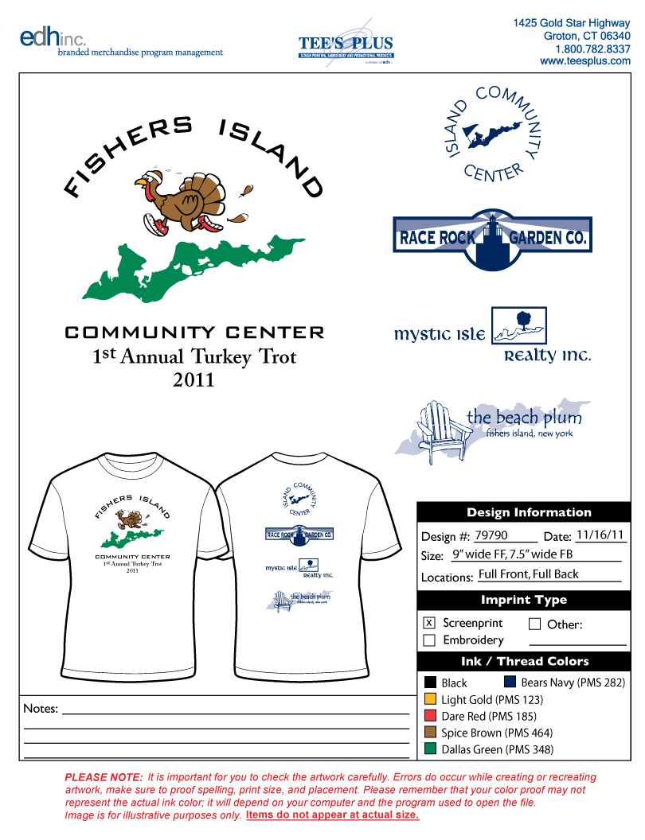

Registration Form
Island Community Center, PO Box 464, Fishers Island, NY 06390
Name_______________________________________________
Address_________________________________________________
City______________________State______Zip______________
Home Phone____________________
Work Phone_____________________
Email________________________________________________
Age_________________ Male_____ Female____

T-Shirt Size: please circle size

Adult Small Adult Medium Adult Large Adult XL

Please circle your divisions:

18 & Under Under 30 Under 40 Under 60 Over 60

Release and waiver (Please Read and sign)
I know that running is a potentially hazardous activity. I should not enter and run unless I am medically able and properly trained. I also know that, although police protection might be provided, there could be traffic on the course route; therefore, I assume the risk of running in traffic. I also assume any other risks associated with running this event including, but not limited to, falls, contact with other participants, and the effects of weather and conditions of the road. I understand I am solely responsible for my own safety while traveling to and fro m or participating in this event.
Knowing these facts and inconsideration of your acceptance of my entry, I hereby for myself, my heirs, executors, administrators, or anyone else who might sue on my behalf covenant not to sue, and waive, release, and discharge the sponsors or contributors to this event, any race officials, volunteers, the city and police agencies, their representatives successors or assignees from any and all claims of liability for death, personal injury, or property damage of an y kind or nature whatsoever arising out of, or in the course of my participation .
The release form and waiver extends to all claims of every kind or nature whatsoever, foreseen and unforeseen, know n and unknown. The undersigned further grants full permission to us e any photographs, videotapes, motion pictures, recordings, or another record of the event for any purpose. Minors will be accepted with a parent’s signature.

____________________________ _________________
Signature Date

