Join us for behind the scenes of CHANGING SHOES… A hilarious talk about life on the road across America with Tina McPherson and the Parsons Sisters!
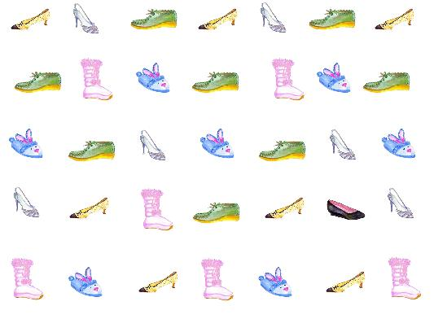


Hosted by the
Fishers Island Library

Wednesday, July20th 5:30PM
Union Chapel

