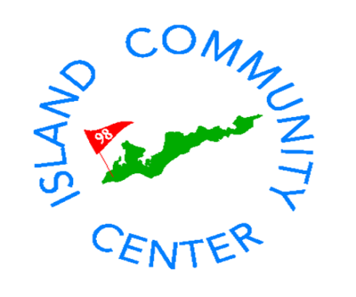
The Island Community Center
invites you to join us on
Friday, November 16th
5:30-7:30pm
for an Open House to welcome
Karen Goodwin and her family
to the Island
Enjoy tastings from the Community Center Café
and wine and beer

