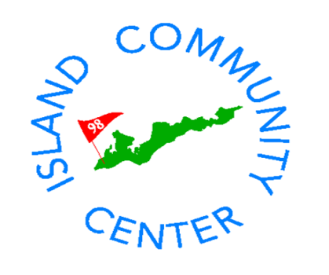

**The Island Community Center**

**invites you to join us on**

**Friday, November 16th**

**5:30-7:30pm**

**for an Open House to welcome**

**Karen Goodwin and her family**

**to the Island**

**C:\Users\Admin\AppData\Local\Microsoft\Windows\Temporary Internet Files\Content.IE5\0CNQN9P6\MC900241287[1].wmf**

**Enjoy tastings from the Community Center Café**

**and wine and beer**