Royal Wedding Party
Island Community Center
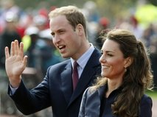
April 29th at 6:00AM
Live from Westminster Abbey!
Doors open at 5:30am
Menu: Coffee, Tea, Scones,
Baked French toast.
FREE!! Everyone welcome!
GET UP EARLY AND Come watch a historical event on the BIG SCREEN!

