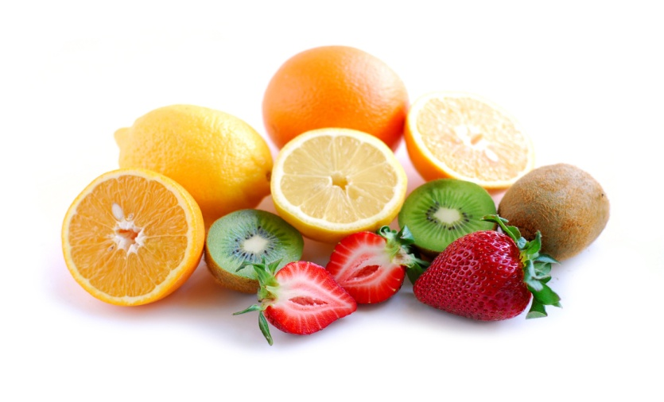
ALL NEW!!!
ISLAND COMMUNITY CENTER NOW OFFERS
RAW FOOD CLASSES
Monday July 16, 23, & 30
5 pm – 6:30 pm

Learn hands on how to prepare easy delicious food
Take home over 15 new recipes
Learn new techniques and tips
Discover how to replace your favorite recipes with their healthier raw versions
Eat a healthy raw dinner at the end of each class
By the end of July you will have more energy, less mental fog, clearer skin, less toxins in your body, and other health improvement specific to you
There are only a few spots left but it’s not too late to sign up!!
CALL TODAY either ICC @ 788-7683 or Annie McPhail @ (860)287-9980

